The following overview of a Schema describes how the different classes/objects relate to one another.

This overview pretty much corresponds with what was agreed upon during the last developer summit in August 2006.

Hierarchies and a security layer need to be added to this model.
Also note that the used locale (en_US : English (American)) is already available in the Schema meta-data but left out here for simplicity.

Physical and business tables/columns, views and categories are also referred to as model elements here after.

This is how it looks like in the Pentaho Metadata Editor:

The next schema explains that most model elements have an attribute known as a concept.

Concepts are basically a collection of one or more Concept properties (ConceptPropertyInterface).
Concepts can have a parent concept (a predefined list of settings like font, color, mask, etc) and/or an inherited concept. The inherited concept can be the concept of another model element, for example a business column inherits the concept from a physical column.

Parent properties are a nice way of setting sane defaults for the different types of columns in a model. The idea here is to have all Ids in a model inherit from a centrally defined concept.
We have an editor for that in the Metadata Editor application:

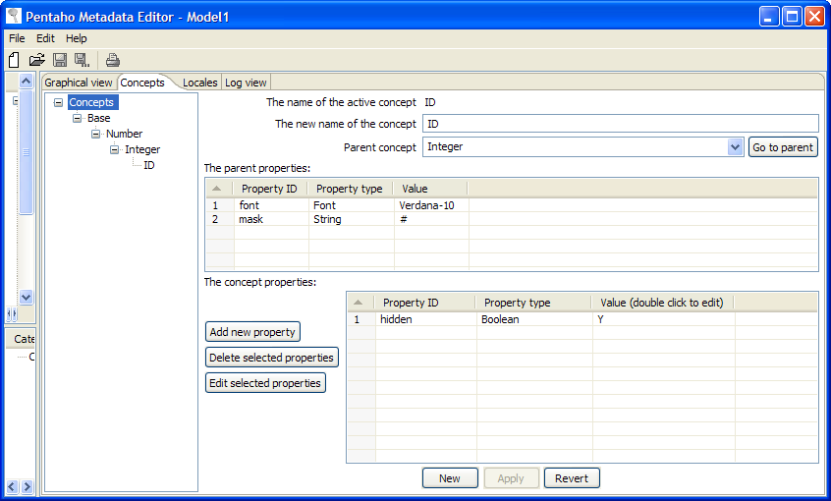

Inherited properties are practical in the cases where a single physical table (Time dimension) is mapped to multiple business tables. You only need to manage the meta-data properties in one place and the business table inherits from the physical table.

In those cases where we want to override properties set in the parent or inherited concept, we can set child properties.

This idea is shown in the following Metadata Editor dialog:

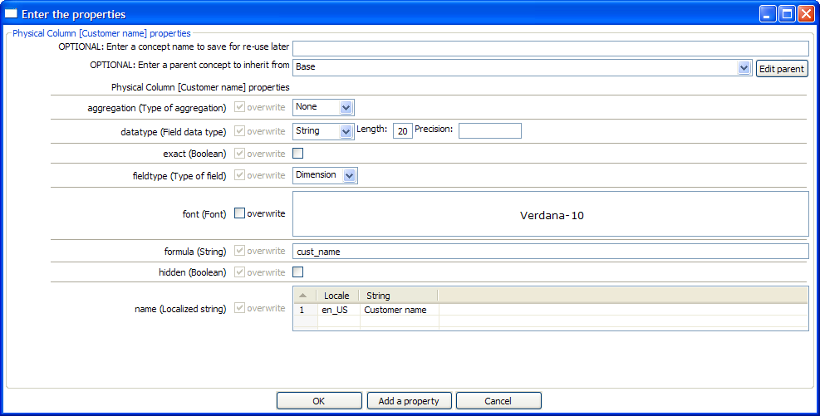

The “overwrite” option is disabled for those options that are defined only in the concept attached to the physical column.
However, if there is an option that is defined in a parent or inherited concept, you will see the option enabled. In this example we would be able to set another font for this particular column.

